|  |  |
| --- | --- |
| **Key Process Step** | **5-Sensor Module SUB ASSEMBLY** |
| **Cell #** | * 1. Test Input and Output PZT   2. Put Brass tube base in Teflon holder   3. Insert PZT Base caps-   4. Insert input and output PZT’s around PZT   5. Screw input and output PZT caps into brass base   6. Insert Thermistor (T/C) into brass base   7. Mount SS shell onto brass base   8. Solder input and output PZT and T/C wire to SM PCB.   9. Snap Soldered SM PCB into PCB Cavity   10. Adhere PCB cavity to SS shell.   11. Place completed SM in transportation cart   12. Conduct Pressure test. |

1. **Safety Requirements**
   1. ESD Procedures Required? Yes, for handling the SM PCB.
   2. PPE required. Glasses must be worn when soldering.
   3. Other Safety issues: Soldering Iron is Hot. Take care in using it.
2. **Tools and Fixtures**
3. **Bill of Material**

|  |  |  |
| --- | --- | --- |
| **Sensor Module sub Assembly** | | |
|  | **15 mm SM base sub-assembly** | |
|  |  | **Brass tube with flow inserts** |
|  |  | **Inlet PZT transducer (red and black wires)** |
|  |  | **Outlet PZT transducer (white and black wires)** |
|  |  | **14\*1.8 oring (black)** |
|  |  | **12\*1.5 oring (orange)** |
|  |  | **16.5\*9.4\*3 oring (pre mounted on PZT)** |
|  |  | **PZT Base Caps** |
|  |  | **PZT Caps (screw in)** |
|  |  | **18 x 2.0 oring (brown)** |
|  |  | **Thermistor with gasket** |
|  | **blue plastic retaining ring** | |
|  | **SS shell and PCB subassembly** | |
|  |  | **SS shell** |
|  |  | **SM PCB** |
|  |  | **SM PCB Housing** |
|  |  | **2 holed metal top plate** |
|  |  | **Nuts** |
|  |  | **RTV for PZT cavity** |

1. **Procedure**

* 1. Test Input and Output PZT
     1. Insert PZT into tester and conduct test. (P)

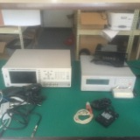

Need photo of the PZT being connected to the test apparatus.

Need photo of what is passing and failing. May need more words

* + 1. Put passing parts into inventory bin,
    2. Label failed parts with NCMR tag and put in NCMR bin.
  1. 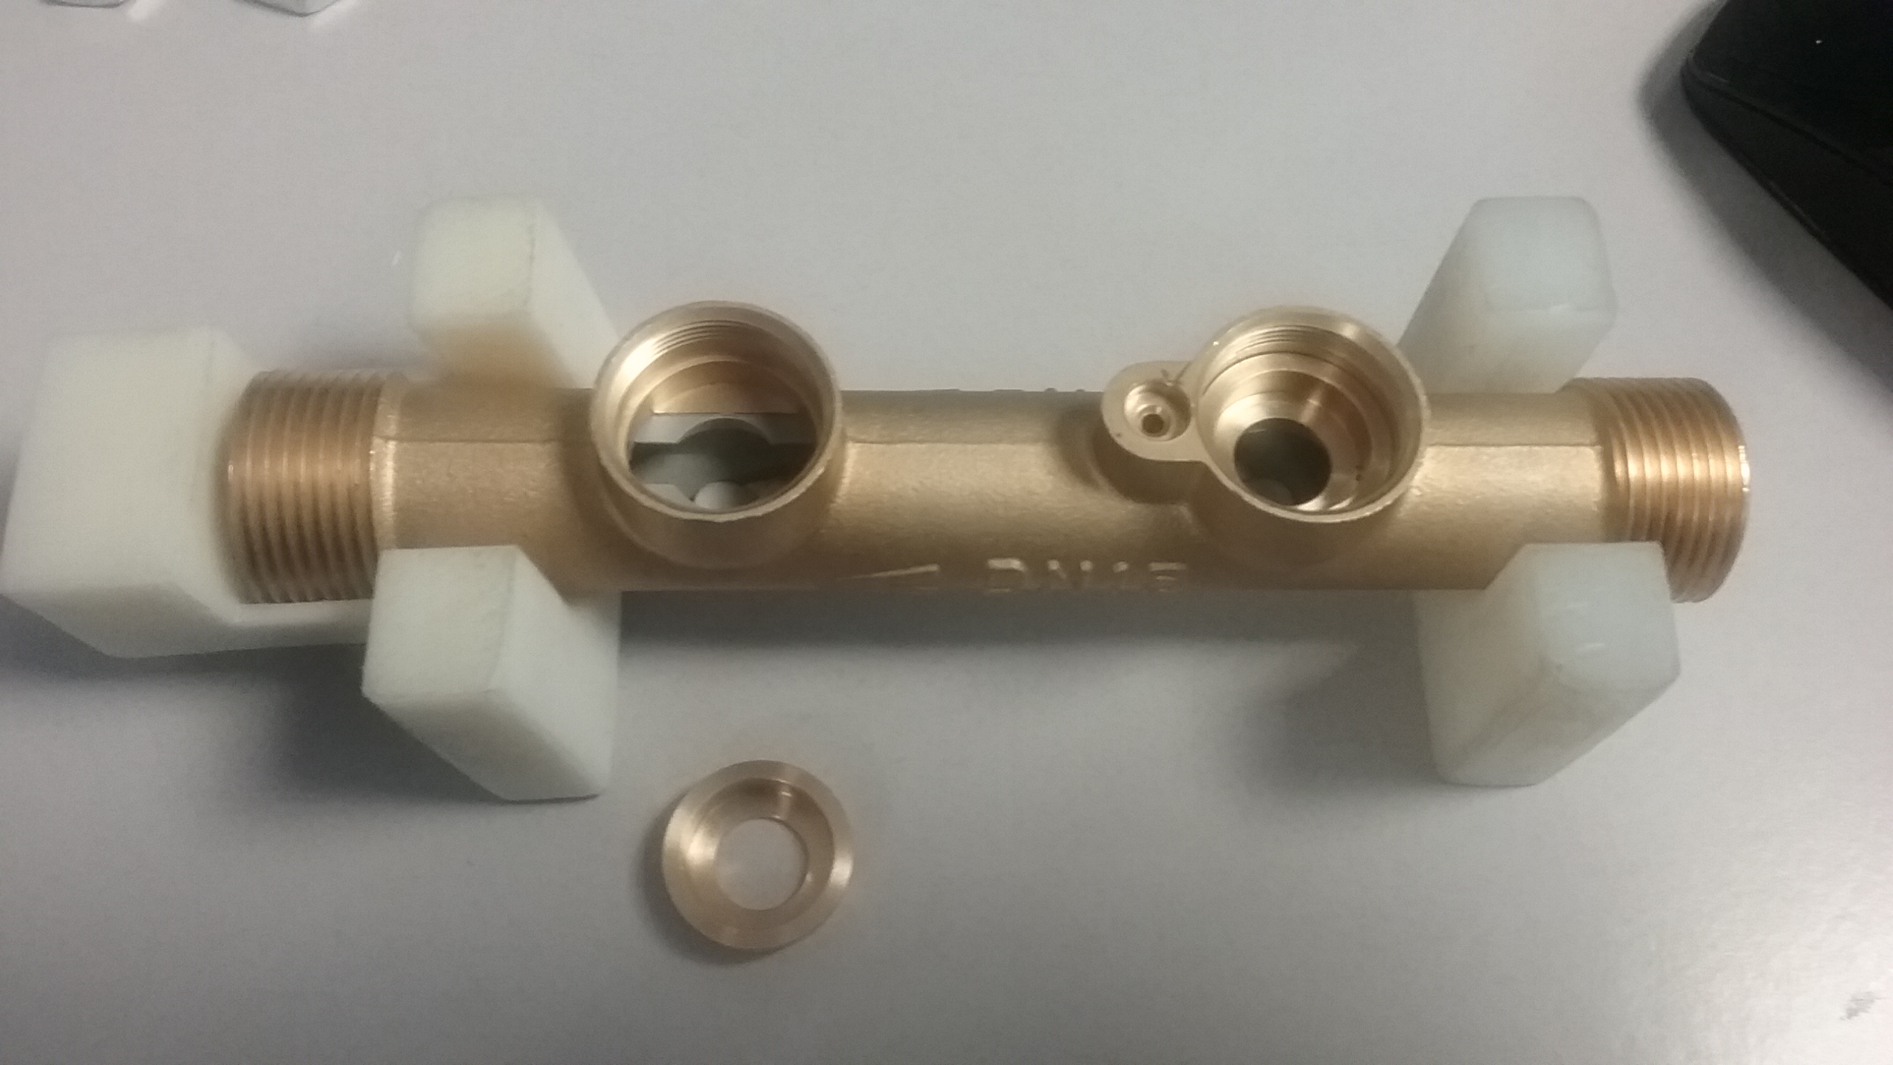Put Brass tube base in Teflon holder-with flow arrow pointing towards closed end of holder. (P)

Then Insert 2 of item 14\*1.8 black O-Ring on shelf of inlets and 2 outlet PZT base cap shelfs. (P) cap shelfs. (P) the PZT base cap (P)

Place the DN15 Brass Tube in the fixture

* 1. 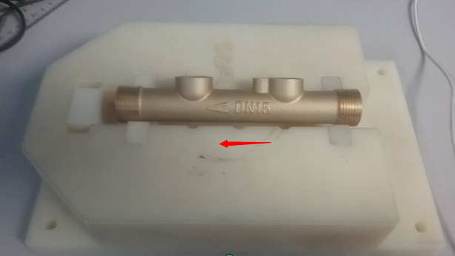Insert PZT Base caps-into in inlet and outlet PZT cavities in Brass tube, making sure top flange of cap sits squarely on tube shelf. (P).

Then Insert 2 of item 14\*1.8 black O-Ring on shelf of inlets and 2 outlet PZT base cap shelfs. (P) cap shelfs. (P)the PZT base cap (P)

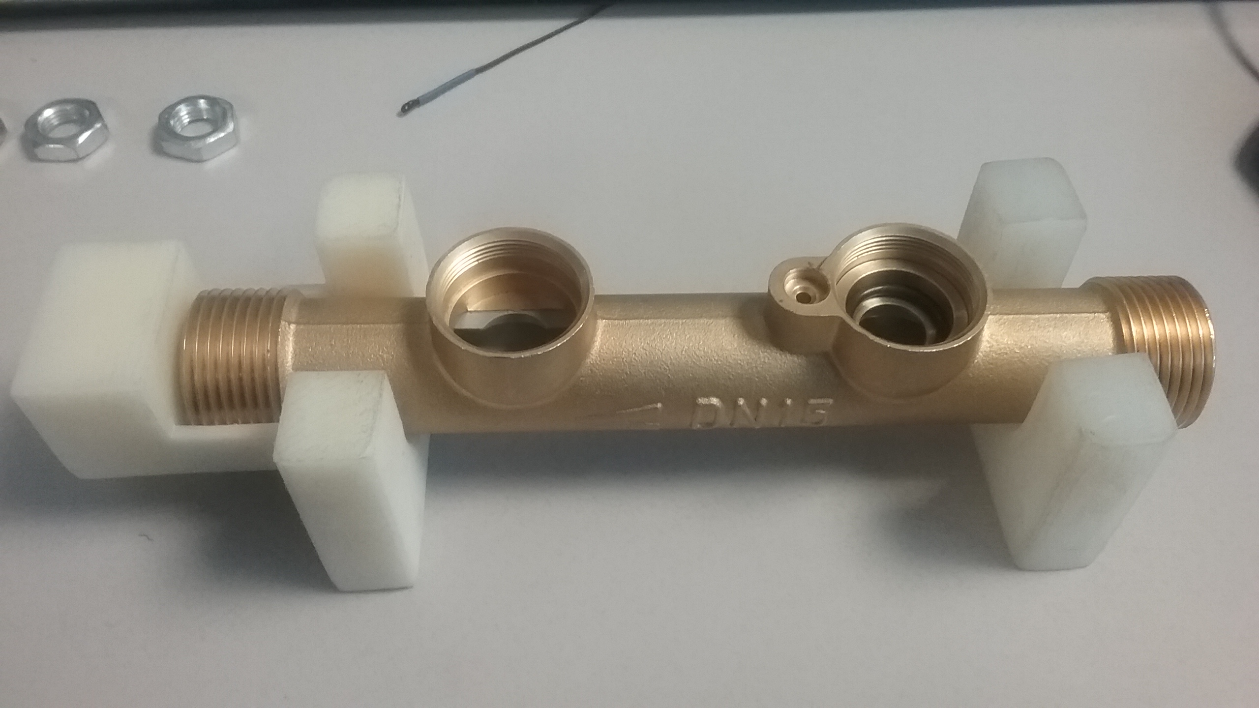

* 1. Insert input and output PZT’s into Brass base caps making sure the bottom of both PZT’s fit squarely in the brass base cavity. (P).

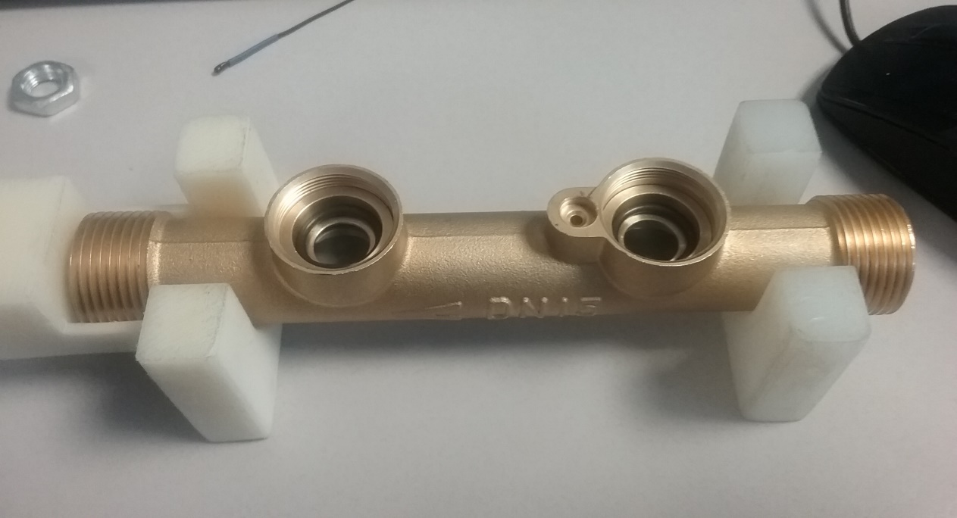

Brass base caps making sure the bottom of both PZT’s fit squarely in the brass base cavity cap shelfs. (P)cap shelfs. (P)the PZT base cap (P)

1. Then insert Flaqt Orange Oring Part Number 18 around PZT and on top of the PZT base cap (P) and place into the DN15 Tube base.

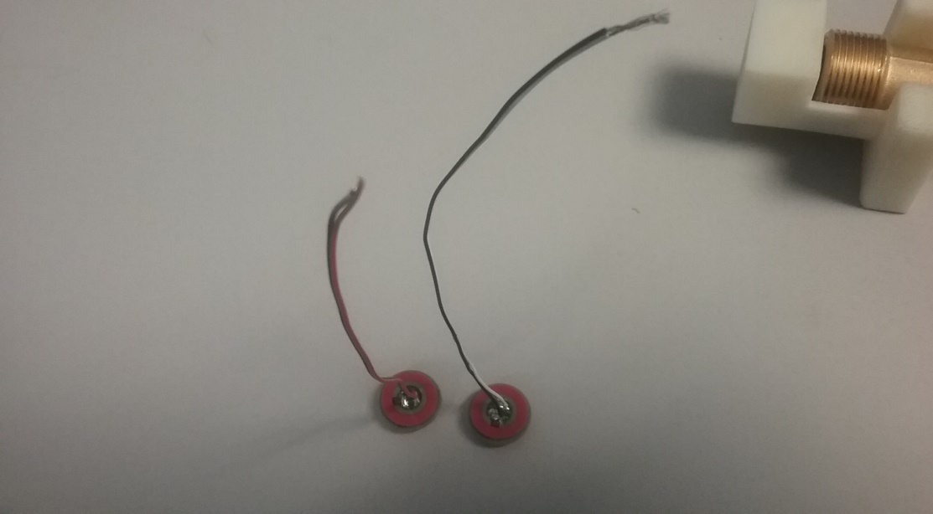

Then insert Orange 18\*2.0 oring around PZT and on top of the PTZPZT base cap (P)

1. Place the Orange round oring into PTZ Screw Cap, then Place the Black/ White PTZ to the left of the flow arrow (right side of the Tube body) and place the Red/Black wire PTZ on the left of the flow tube. 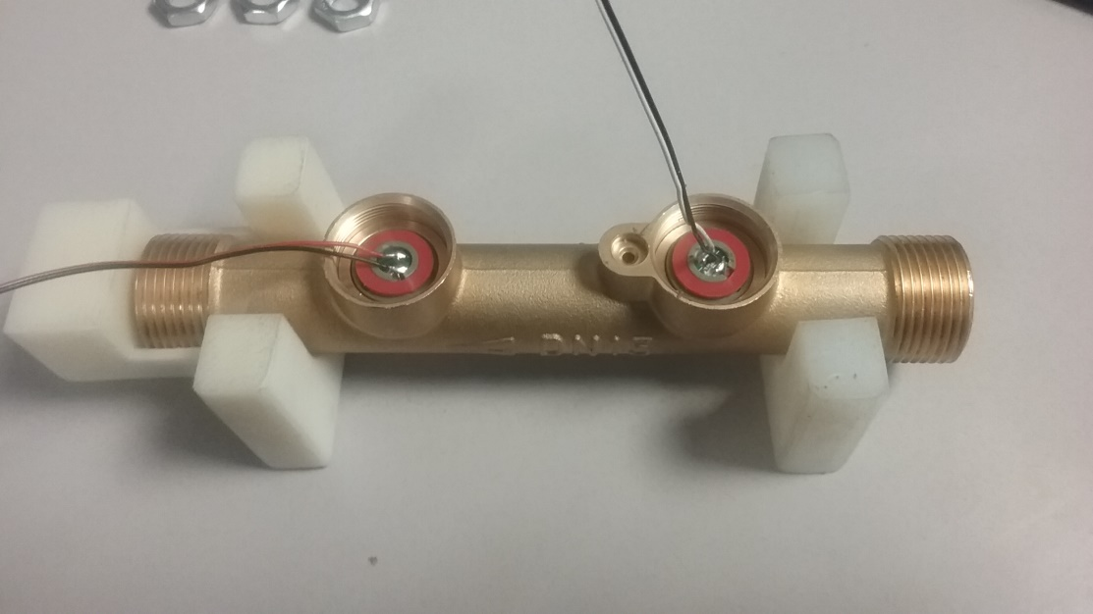
   * 1. Feed the wires of the PTZ’s though the PTZ screw caps. With the wire through the hole of the screw cap torque the screw cap until the Screw cap bottom out into brass base Feed input and output PZT wires through the PZT screw caps (P)

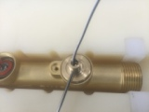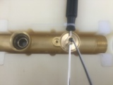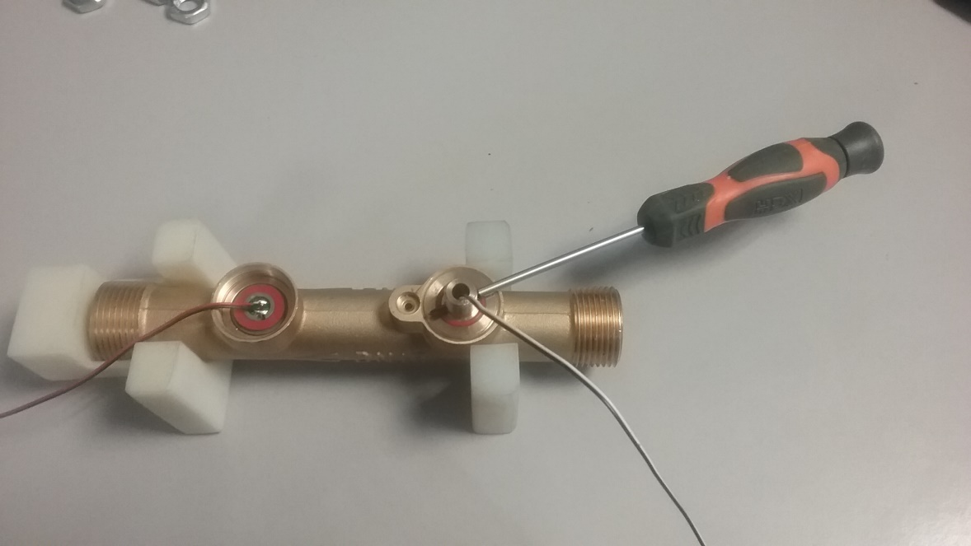

Feed the wires of the PTZ’s though the PTZ screw caps. With the wire through the hole of the screw cap torque the screw cap until the Screw cap bottom out into brass base Feed input and output PZT wires through the PZT screw caps cap (P)

* + 1. Hand tighten the screw cap and then final tighten screw cap by inserting shaft through the two tightening holes in the screw cap and tightening the screw cap such that the shaft is perpendicular to the axis of the brass tube (P)
    2. Insert two orange 12\*1.5 O-rings into groove in top of screw cap, making sure the O-Ring are well seated in the cavity.

|  |  |
| --- | --- |
| C:\Users\Richard\AppData\Local\Microsoft\Windows\INetCache\Content.Word\20170501_120159.jpg |  |

* 1. Insert Thermistor (T/C) into brass base

Place a drop of superglue in bottom of Thermistor cavity in brass tube located near input PZT cavity (P) Insert Thermistor tip into cavity making sure the tip is in contact with brass base. You can feel it come to a stop when it is inserted into the cavity. (P). Then press thermistor gasket into gasket cavity until it bottoms out. (P)

Thermister Wire

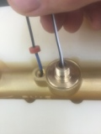 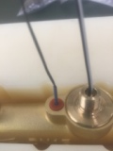

* 1. Mount SS shell onto brass base
     1. Slip blue plastic retaining ring over SS shell with flange facing upwards. (P)

|  |  |
| --- | --- |
| C:\Users\Richard\AppData\Local\Microsoft\Windows\INetCache\Content.Word\20170502_111735.jpg |  |

* + 1. Thread input, thermistor and output wires through corresponding holes in Stainless Steel Shell (SS shell). Taking care not to dislodge the thermistor from its cavity. (P)

Thermister Wire

Thermister Wire

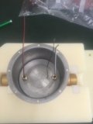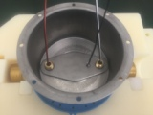

* + 1. Slip SS shell over the threaded tips of the screw in PZT caps. Then thread wires through metal top plate and set plate on bottom of SS shell.

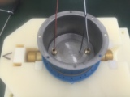

* + 1. Insert input PZT wire through nut and hand tighten(P)Then repeat for output PZT. (P).

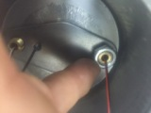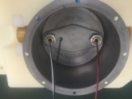

* + 1. Then tighten both nuts using electronic Socket driver with slot for wire in the side of the socket (P).

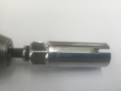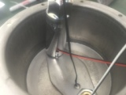

* 1. Solder input and output PZT and T/C wire to SM PCB.
     1. Place SM PCB in alligator clip holder with 4 PZT connectors on left side and 2 T/C connectors on left side.

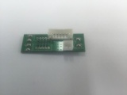

* + 1. Use a fine point soldering iron to melt the upper left solder ball and place red wire from the input PZT in then melt. Allow to cool and check to make sure wire is firmly soldered. Then solder the black wire from the input PZT using same process as above. Repeat on the white wire from the output PZT and finally, repeat on the black wire from the output PZT. First and last solders are shown below.

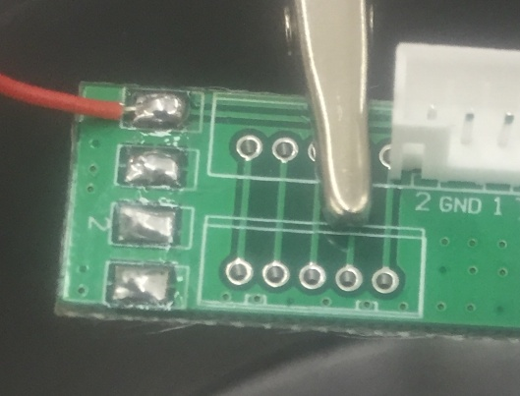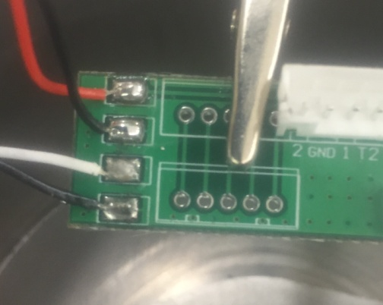

* + 1. Solder the two TC wires to the right side of the board using same process as above. There is no wire orientation.

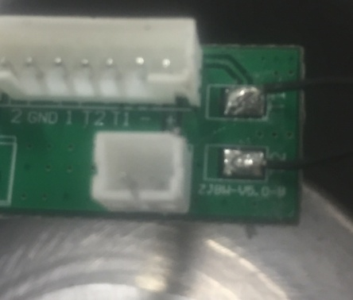

* 1. Check to make sure all the soldered wires are held firmly in the solder ball.

Need photo of a good and bad solder

* 1. Snap Soldered SM PCB into PCB Cavity making sure it is firmly “snapped” in. Then remove protective pad from the adhesive bottom of the PCB Cavity and stick to the bottom of the SS shell as shown.

SM PCB into PCB Cavity

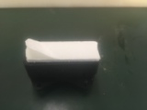 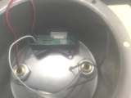

* 1. Place completed SM in transportation cart and move to Pressure test area (Argo #4 and #5)

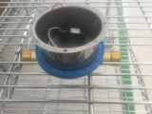

* 1. Conduct Pressure test.
     1. Place (x#) units into pressure test machine, taking care that they are well seated in the Teflon heads.

Need Photograph of SM SA being put into Teflon holders showing o ring. 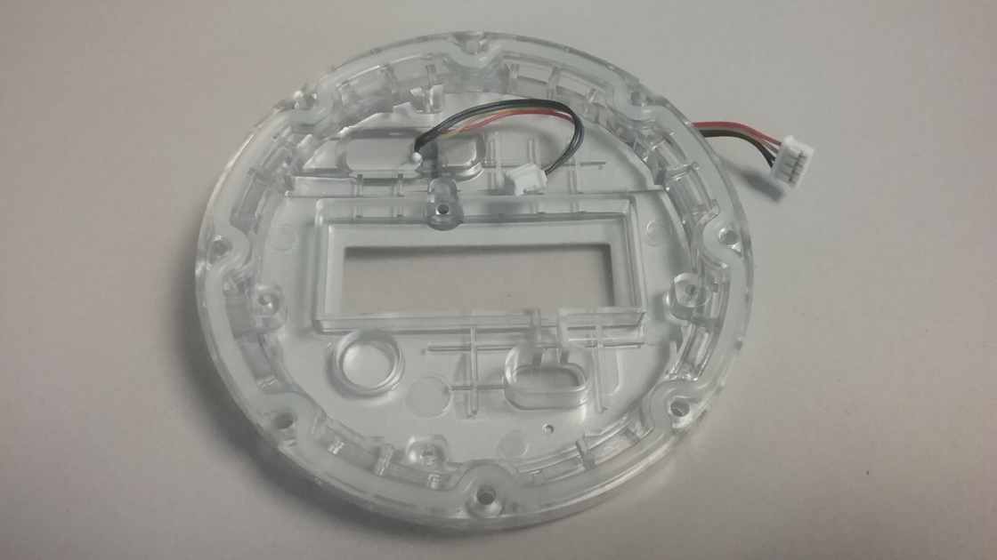

Oring Seal for Electronics

Need Photo of unit fully loaded

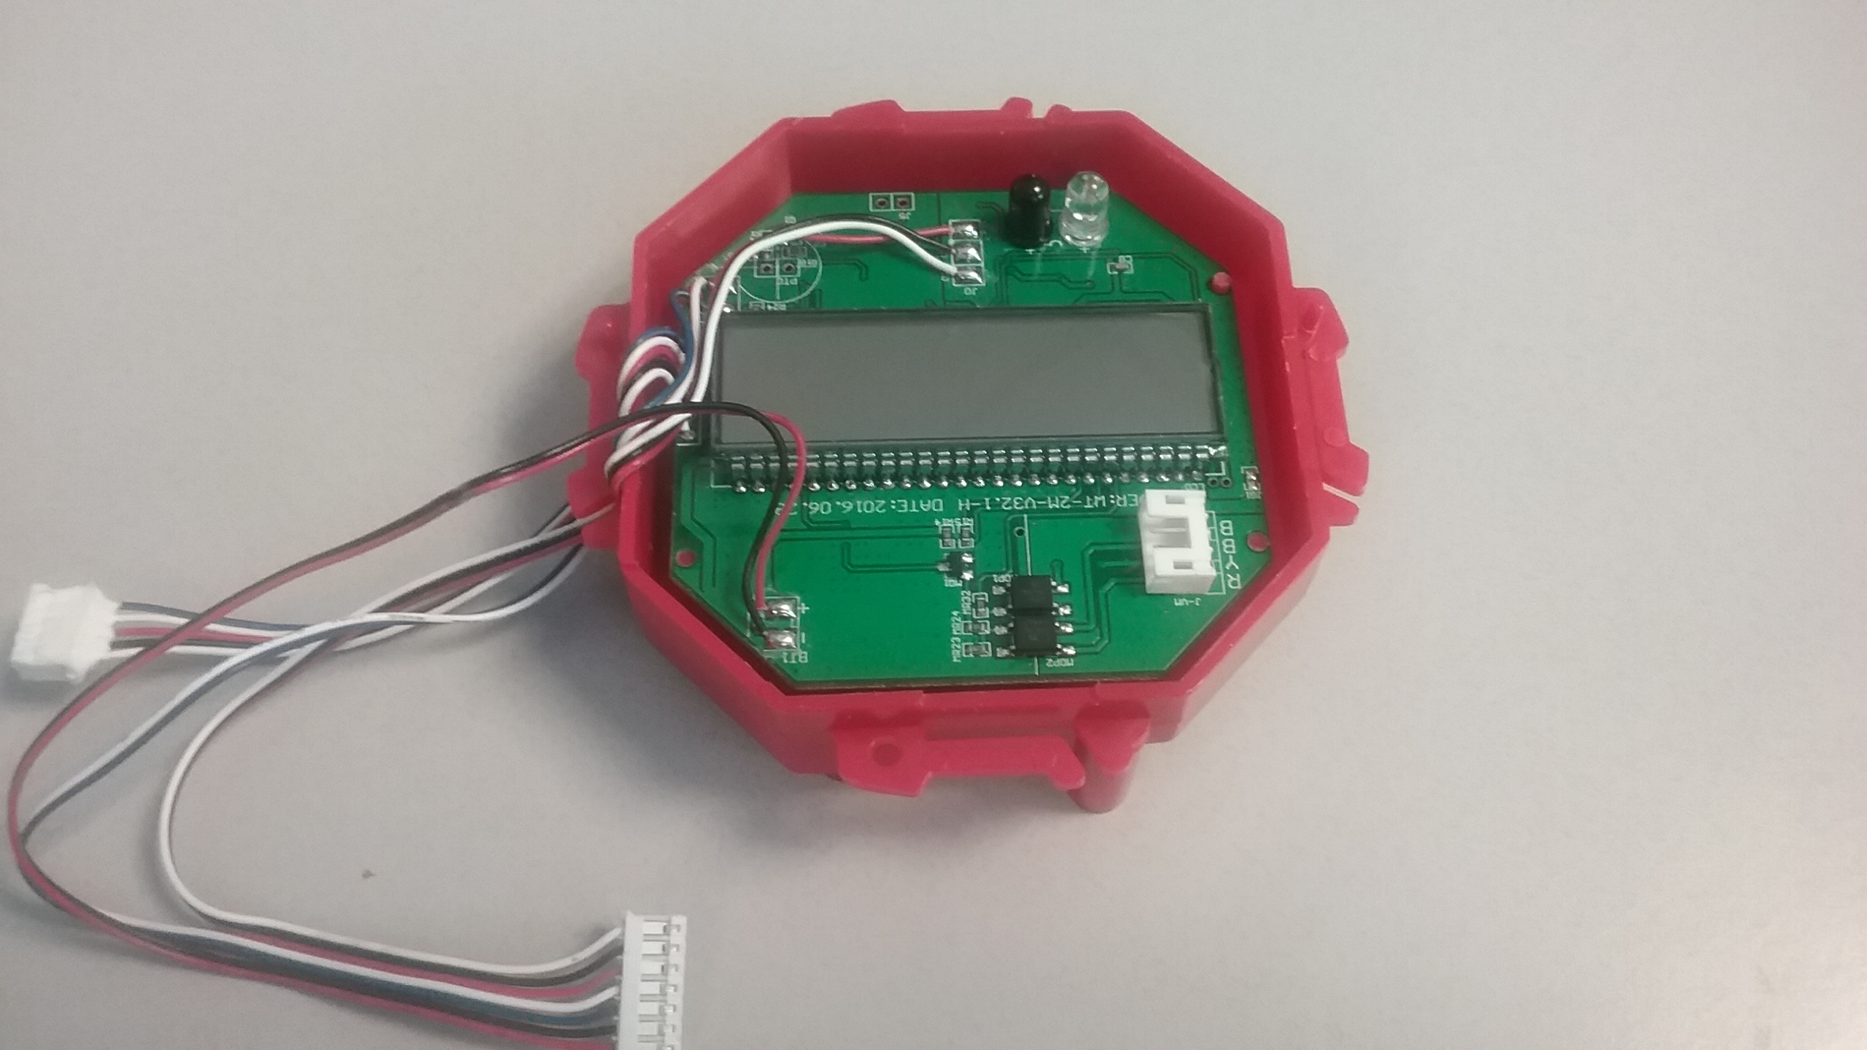

* + 1. Fill SM units with water and purge air.

Need photo of control board that shows how to fill SM SA and then purge air.

* + 1. Start the pressure test and check units for leaks.

Need photo of control board showing how to start and stop pressure test.

* + 1. When test is finished, dump any retained water out and place passing units back on cart and transport back to the Manufacturing area.
    2. Label failed parts with NCMR tag and put in NCMR bin.
  1. General boiler plate
     + 1. Fill out process traveler and move with parts to next cell
       2. Fill out Bill of materials and move with process traveler
       3. Fill out NCMR card as needed.
       4. Move parts to the next cell.